Langa Township Cultural Experience
Price: R1,300 per person
Half day Tour
Includes all fees, guides, transport & bottled water
Overview
Langa Township, meaning “sun” in isiXhosa, is Cape Town’s oldest township and a vibrant destination for experiencing South Africa’s culture, history, and community spirit. Historical Significance Langa, established formally in 1927 following the 1923 Urban Areas Act, is one of South Africa’s oldest townships and played a pivotal role in the anti-apartheid struggle. It was initially developed to house Black Africans under strict apartheid regulations. The name “Langa” derives from Chief Langalibalele, who resisted colonial authorities and was imprisoned on Robben Island, while “sun” reflects its Xhosa meaning
What to expect
Discover the heart of Cape Town’s oldest township, Langa, on an immersive cultural tour led by local community guides. This experience offers authentic storytelling, vibrant art, history, and real connections with the people who call Langa home.
- See local creators
- Beadworks
- Sculptures etc.
Hotel Pick‑Up & Drop‑Off.
Comfortable, air‑conditioned transport from hotels in CBD, Green Point, Sea Point.
Morning Tour (Most Popular)
- 09:00 – 12:00
This is the best slot — community activity is lively, craft markets are open, and guides prefer this time.
Afternoon Tour
- 13:00 – 16:00
Good for guests arriving later or combining with morning activities.
Private / Custom Times
Operators often allow:
- 10:00 – 13:00
- 14:00 – 17:00
These are used for private groups, cruise passengers, or custom itineraries.
Pricing and Discounted % amounts offered
Group Size | Adult Price | Child Price (4–12 yrs) | Notes
2-3 Guests | R1,300 pp | R650 pp | Standard rate
4–6 Guests | R1,170 pp (10% off) | R585 pp (10% off) | Small-group discount
7–10 Guests | R1,105 pp (15% off) | R555 pp (15% off) | Ideal shared tour size
11–14 Guests | R1,040 pp (20% off) | R520 pp (20% off) | Best value for large groups
15+ Guests | R950–R1,000 pp (custom) | R475–R500 pp (custom) | Schools, corporate groups

🏘️ Welcome to Langa – Cape Town’s Oldest Township
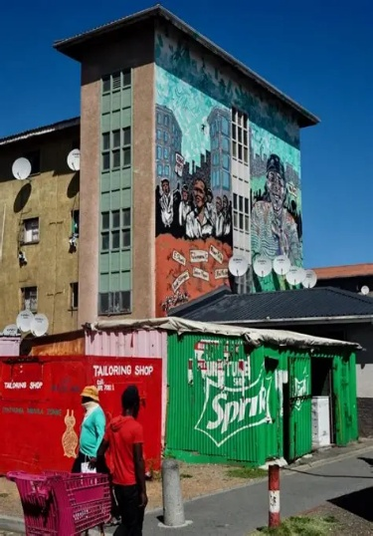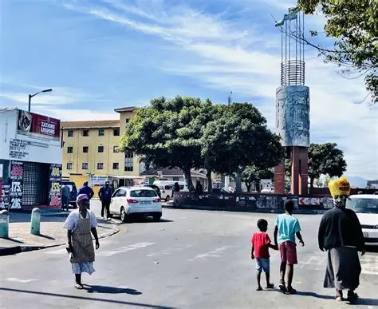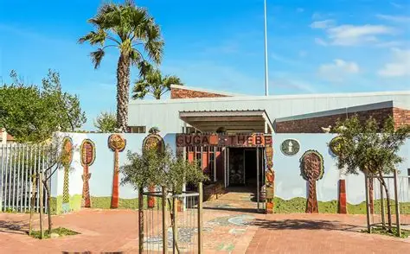
Safety: Langa is considered one of the safer townships for visitors, especially when exploring with local guides.
What’s Included
- Hotel pick‑up & drop‑off
- Professional driver‑guide
- Local Langa community guide
- Guga S’thebe visit
- Cultural walk
- Craft market stop
- Bottled water
- All entry fees
Exclusions
- Lunch
- Personal purchases

